Clinic Services
Pregnancy Resource Center and Women’s Clinic
Chatham County Health and Savannah Care Center Staff are available on campus Mondays from 1pm to 4pm.
For more information about the women’s clinic:
www.chathamcounty.org/health.html and www.savannahcarecenter.org

Substance Education Program
Heads Up Guidance Services provides services to our staff and students at the Health Center on Mondays and Wednesdays from 7pm to 8pm.
For more information about this service:
andreamehugs@bellsouth.net

Campus Outreach
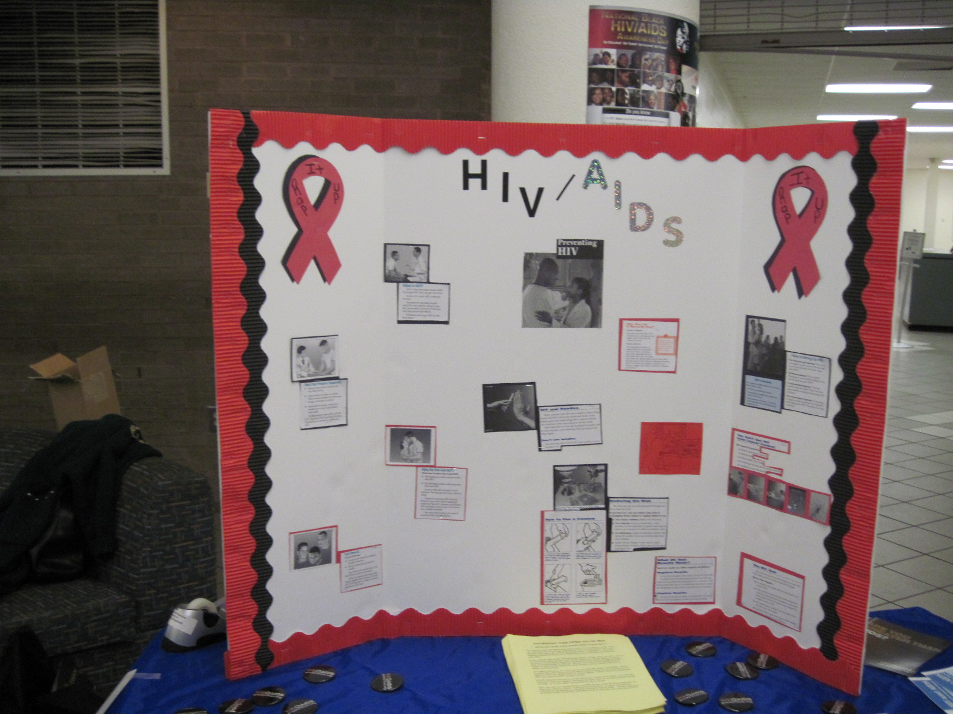
2009 Curtis V. Cooper Annual Health Fair—Located in the King Frazier Student Center. This year there were over 900 participants including faculty, staff, students, and the community at large.
For more information about this service: Curtis V. Cooper Health Center
http://www.chathamsafetynet.org/curtis-v-cooper-health-center/inindex.html

