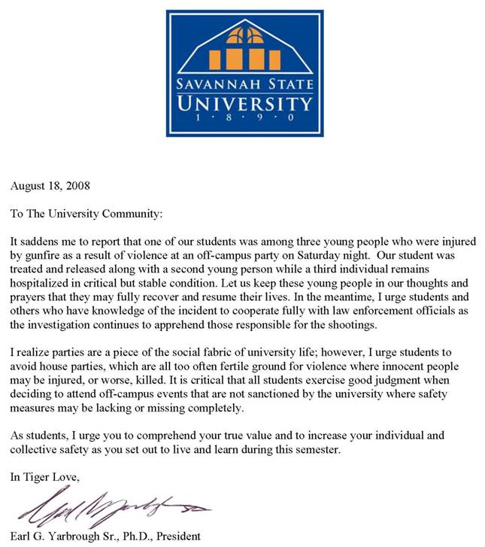Savannah State University

*Members:*

Dr. Adegboye Adeyemo

Dr. Ulysses Brown

Dr. Hae Yeon Choi

*Dr. Tamara Friedrich*

*Dr. Yousef Jahmani*

*Dr. Shinemin Lin*

*Dr. Dorothy Gardner-Martin*

*Dr. Lilian Reddick*

*Dr. Harpel Singh*

*Prof. Henry Taylor*

*Dr. Kazuo Yagami*

*Dr. Lisa Yount*

*Dr. Lisa Yount*

*Dr. Arav Ouandlous*

Faculty Senate

Minutes of the Faculty Development Committee

Time and Location: 2:00p.m. – 2:17p.m.

COBA Faculty Lounge Room 107

Members Present: Adegboye Adeyemo, Ulysses Brown, Yousef Jahmani.

Excused: Hae Yeon Choi, Tamara Friedrich, Shinemin Lin, Harpel Singh.

1. The committee met to hear reports from the three subcommittee meetings.
2. The Distinguished Professor (DP) subcommittee met on 1/31/13 and elected Dr. Jahmani as its chair. Four members were in attendance: Doctors Choi, Jahmani, and Gardner-Martin. Dr. Jahmani reported that the necessary funds to conduct the work of the DP subcommittee are no longer available and requests that President Dozier make these funds available for the committee to operate properly.
3. The Patent/Copyright subcommittee met on 2/06/13 and elected Dr. Adeyemo as its chair. Four members were in attendance: Doctors Adeyemo, Brown, Choi, and Yagami. Dr. Adeyemo asked if there were previous records or minutes from this subcommittee. Dr. Brown was asked to investigate this matter with the Executive Committee members of the Faculty Senate.
4. The Teaching and Learning Grants subcommittee did not meet. Dr. Yount has agreed to convene a meeting of the Teaching and Learning Grants subcommittee on 2/14/2013 at 2:00p.m. in the Dean’s Conference Room 217 of the Social Sciences Building.
5. Meeting adjourned.